|  |
| --- |
| **SEDCO**  **CVM TEAM**  **Survey Question Configurator**  **User Manual** |

Table of Contents

Abstract v

Chapter 1: User Manual 1

# Abstract

Survey Question Configurator is a Windows Application for creating 3 types of questions

1. Smiley Question, where you have multiple options:
   1. The order of the question.
   2. The actual text of the question.
   3. Number of smiley faces.
2. Slider Question, where you have multiple options:
   1. 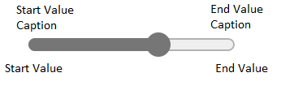 The order of the question.
   2. The actual text of the question.
   3. Start value of the slider
   4. Start value caption of the slider.
   5. End value of the slider.
   6. End value caption of the slider.
3. Star Question, where you have multiple options:
   1.  The order of the question.
   2. The actual text of the question.
   3. Number of stars.

# Chapter 1: User Manual

**1.1 Introduction**

The functionality of this application is to allow its user to manage collection of questions, where you can view, add, edit and delete.

**1.2 How to use**

* First you have the main screen. It has multiple controls and buttons, divided into numbered sections as the figure shows below:

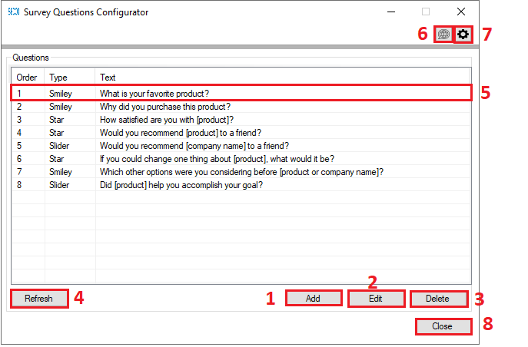

1. Add a question.
   * Opens a new screen to add a question.
2. Edit a **selected** question.
   * Opens a new screen to edit a question.
3. Delete a **selected** question.
   * Shows a conformation screen.
4. Refresh question’s list.
   * Re-fetch data from database and view it to the list.
5. **Double clicking** a question open its **editing** screen.
   * Same action as point 2 above.
6. Changes language settings.
   * Opens a new screen to change application’s language.
7. Change the connection to a database setting.
   * Opens a new screen to change connection settings.
8. Close the application.
   * Causes the application to exit.

**1.3 Operations**

**1.3.1 Add a question**

Secondly, if you press “**Add**” you will open “Add A Question” screen:

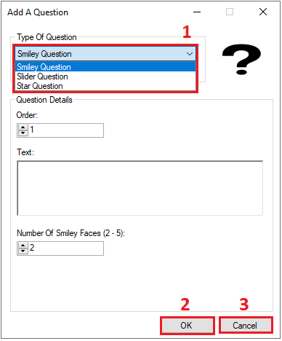

Also divided into 3 section:

1. Continue with your selections and inputs.
2. Add the question.
3. Close the application.

* There are 3 types of questions to add.

1. Smiley faces question

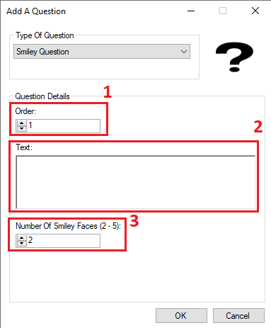

* 1. Order of the question.
     + Can **NOT** be repeated.
  2. Text of the question.
     + Can **NOT** be empty nor extend over 4000 character.
  3. Number of smiley faces (2-5).
     + **MUST** be in the range of (2-5) **inclusive**.

1. Slider question

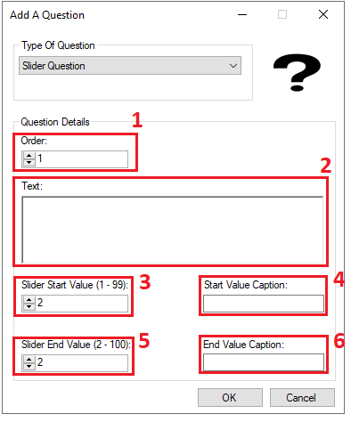

* 1. Order of the question.
     + Can **NOT** be repeated.
  2. Text of the question.
     + Can **NOT** be empty nor extend over 4000 characters.
  3. Start value of the slider (1-99) **inclusive**.
     + Start value must be **less** than end value.
  4. Start value caption.
     + Can **NOT** be empty not extend 100 characters.
  5. End value of the slider (2-100) **inclusive**.
     + End value must be **larger** than start value.
  6. Start value caption.
     + Can **NOT** be empty not extend 100 characters.

1. Stars question

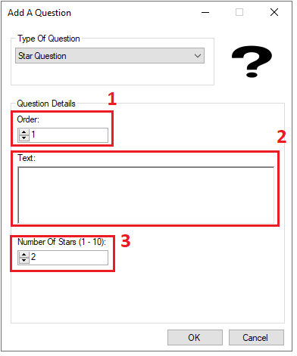

* 1. Order of the question.
     + Can **NOT** be repeated.
  2. Text of the question.
     + Can **NOT** be empty nor extend over 4000 characters.
  3. Number of stars (1-10) inclusive.
     + Must be in the range of (1-10) **inclusive**.

**1.3.2 Editing a question**

By selecting a question and pressing edit, or doubling clicking a question.

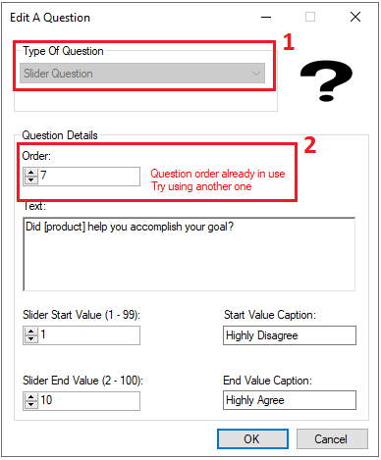

1. Question type **cannot** be changed.
2. Question order cannot be repeated.

**1.3.3 Deleting a question**

By selecting a question and pressing delete button.

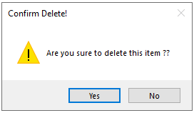

**1.3.4 Troubleshooting**

1. If you try to edit or delete a question that doesn’t exist while list hasn’t refreshed yet this error will appear.
   * 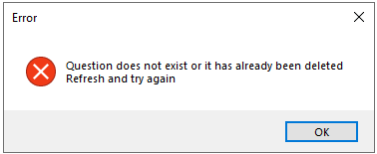
2. If database connection error happened while performing an operation this error will appear.
   * 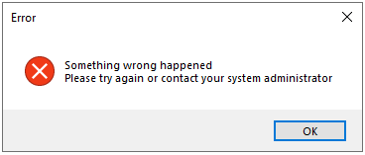
3. If you try to add or edit a taken question order this error will appear.
   * 

**1.4 Language settings**

When pressing language settings button, a new appears to change the language of the application as shown in the figure below.

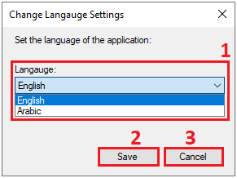

1. Chose the preferred language of the application.
2. Save settings.
3. Close the screen without saving any settings.

*Note: Changing the language will cause the application to **restart**.

English:

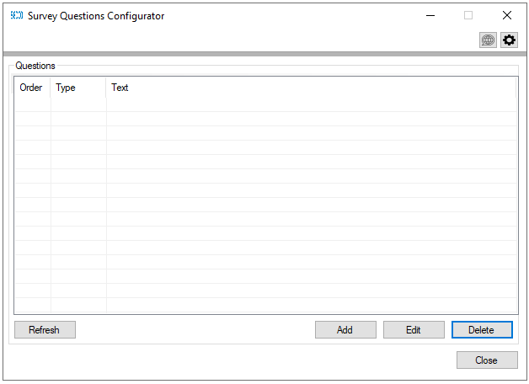

Arabic:

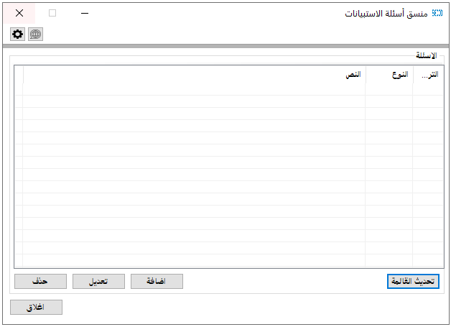

**1.5 Connection settings**

**1.5.1 Adding/Changing connection settings**

When pressing language settings button, a new appears to change the language of the application as shown in the figure below.

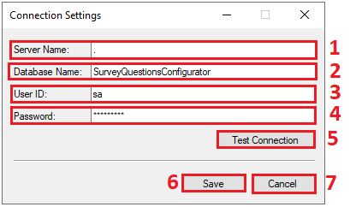

1. Enter the name of the server you want to connect to.
2. Enter the name of the database you want to connect to.
3. Enter the ID of database user.
4. Enter the password of that same user.
5. Test and check the connection of the entered data.
6. Save your settings.
7. Close without saving any settings.

\***Note**: Testing connection settings may cause the application to hang for a short time, which is a normal behavior.

**1.5.2 Troubleshooting**

1. If the database or its connection went offline. Also wrong connection settings will cause the application to go into offline mode as shown in the figure below.

